**Limits**

* Every server will have limited Hardware resources, these resources can cater only certain limit
* Example Scenario:
  + Each Server component like availability checker can respond to 5000 parallel users/requests. But right now, we have 10000 users
* Solution for the above scenario is Scaling. Scaling is of two types
  + Vertical:
    - Increase hardware resources of the current server
  + Horizontal:
    - Increase number of servers doing the same job

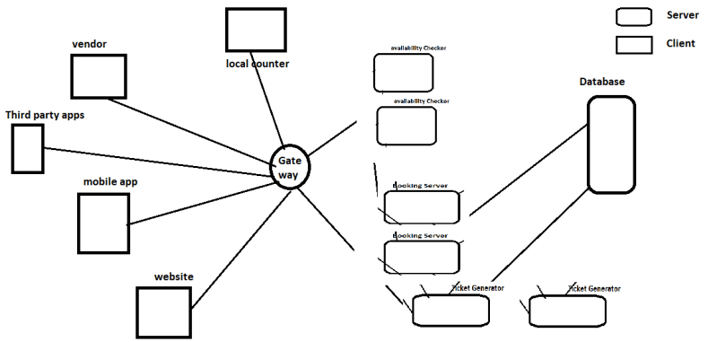

* One unsolved puzzle over here is what will we do if the traffic comes down to 3000 users. We need a way to scale out/scale up (increase) and scale in/scale down (decrease) the number of servers based on demand
* In all the cloud, the scale in and scale out is supported and also referred as elasticity.

**Terms So far**

* Availability:
  + A measure of system uptime.
  + If your system is up for almost all the time it is considered to be Highly Available.
* Fault Tolerance:
  + Capability of system to recover from failures/faults
* Elasticity:
  + Capability of System to Scale up or down depending on need of the user is considered as elasticity

**Virtualization**

* Allows to create multiple simulated environments or dedicated resources from single physical hardware system.

**Understanding virtualization**

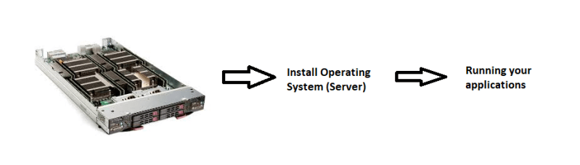

* To run applications, we follow the above workflow
* When the applications dont use your hardware resources to the maximum potential, ROI (Return on Investment) is very low 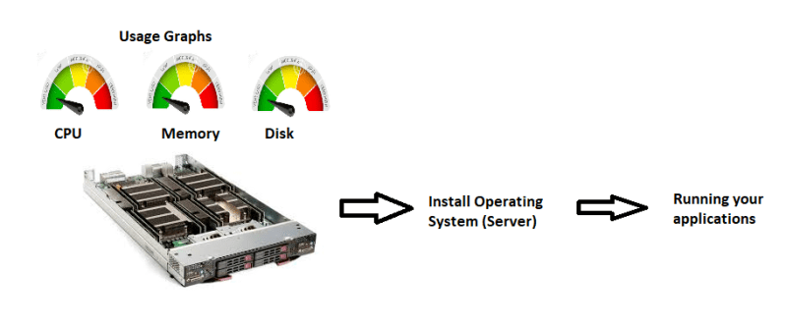
* Rather than using one operating system on the physical server, we can create multiple vms on the same physical server. This kind of virtualization is called as Server Virtualization 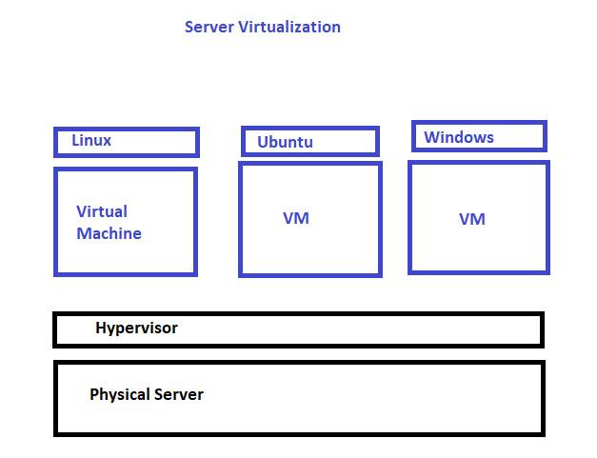
* Every VM gets
  + Virtual disk
  + is connected to virtual network using virtual socket
  + a CPU and memory (virtual)
  + Has some Opertaing system
* Server virtualization is supported by Softwares like VMWare ESxi
* All the clouds use Server Virtualization for creating virtual machines
  + Amazon calls it as EC2
  + Azure calls it as Azure VM 